Assignment 2 SQL Advanced SQL

Total points: 36

This assignment should be completed individually. For each problem, submit your SQL statement and a screen shot of the SQL results in a single Word document or pdf file. Submit the file via eLearning.

I recommend creating a new user and workspace named after your netid, log in as that user and load the database script (provided in this week's assignment folder). Before you attempt to write any SQL queries, familiarize yourself with the database structure and data. I have provided a relational diagram and sample data for this database.
Submit both the SQL statements and the screen prints of the outputs from Oracle. (2 points for the screen shots). Be sure the workspace name is included in your screen shots!!!
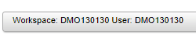
Cars ERD
Tip:
counries.continent = car_makers.country; car_makers.id = model_details.maker; model_details.model = car_names.model; car_names.id = car_details.id
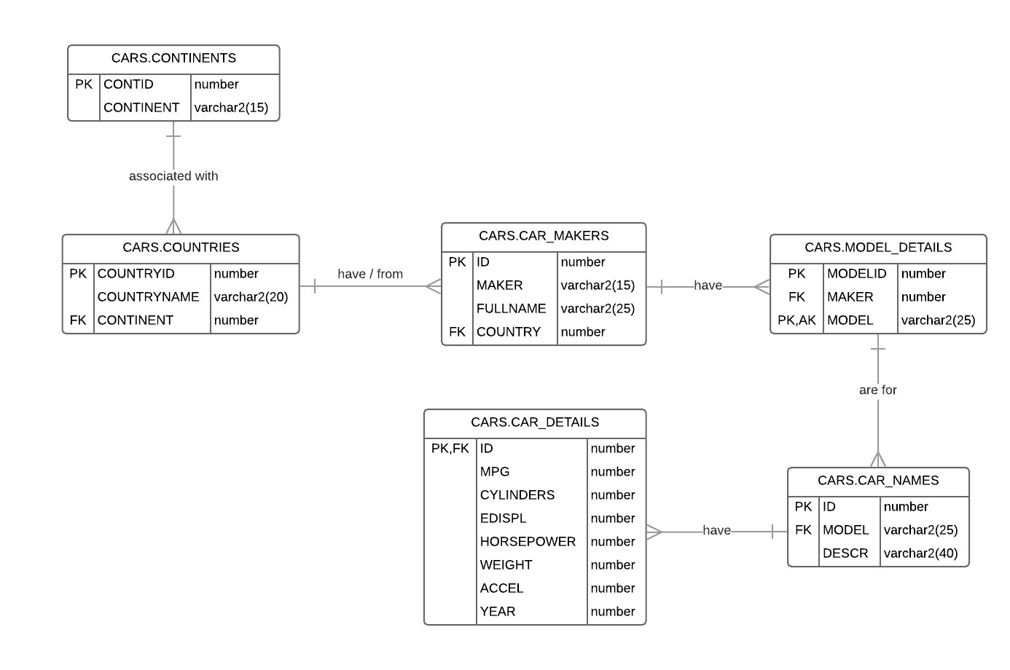
Each question is worth 6 points each. 2 point deduction for missing screen shots. 2 point deduction for missing netid as workspace name or netid as username (oracle live).

- Provide a list of car details for the cars that were made by car makers in Germany. Use nested subqueries to minimize the number of joins that you will need. (Use a minimum of 2 nested queries). Display the year and the model as one field called Model and display the mpg, cylinders, and horsepower as one field, each column separated by ‘-‘ called Specs. Order by year.
Sample output listing (not all rows displayed)

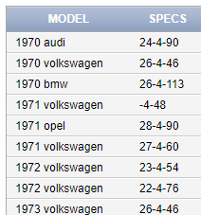

BONUS – if the MPG is null, display 0 in its place (HINT – use a function) +3 pts
select year ||' '|| model as "MODEL", (select SPECS from car_details cd1 where cd1.id = cd.id) as "SPECS"
from car_names cn, (select id, year, nvl(mpg, 0) ||'-'|| cylinders ||'-'|| horsepower as "SPECS" from car_details) cd
where cn.id = cd.id
and cn.model in (select md.model from model_details md, car_makers cm
where cm.id = md.maker
and cm.country = (select countryid from countries where countryname like '%germany%'))
order by year
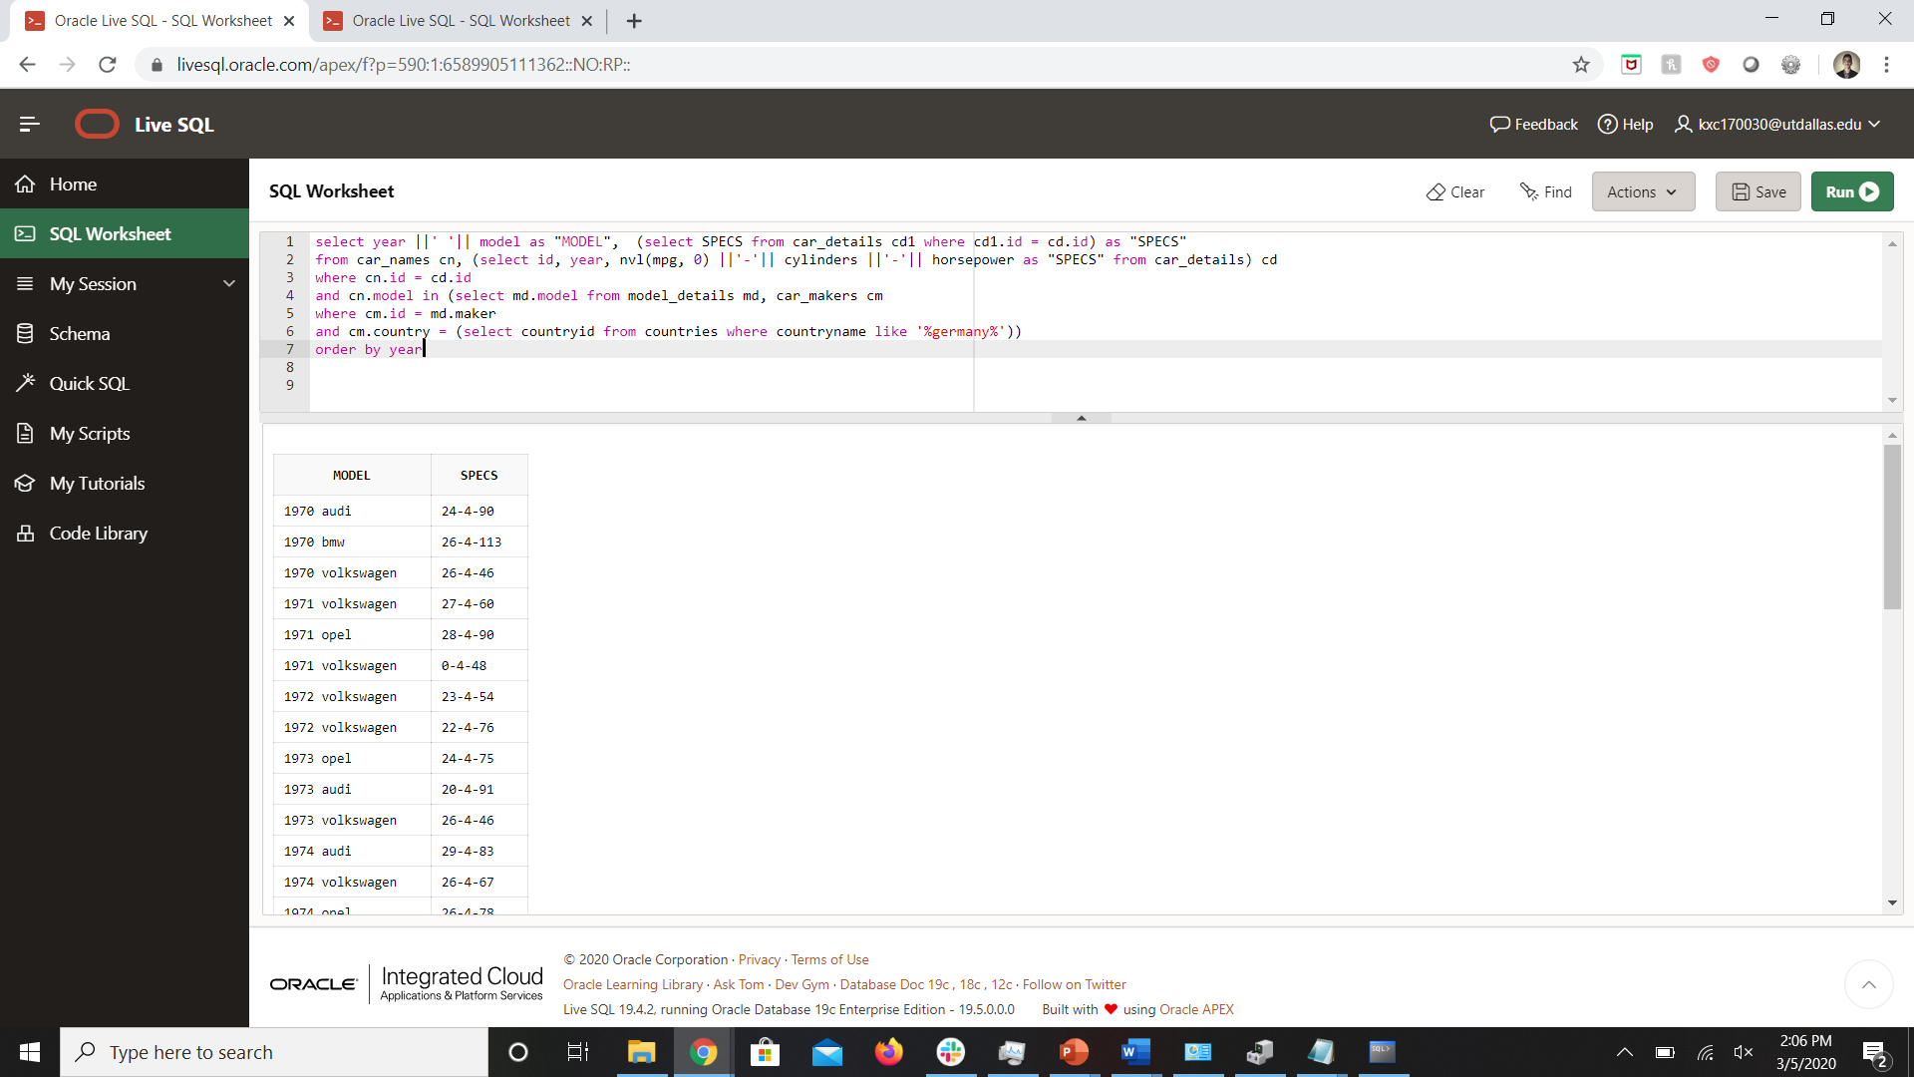

2. Provide a list of models that have an average MPG for their cars that is less than the overall average for all cars. Display the average MPG for each model, the overall average for all models, and then the difference. Exclude the nulls from your calculations. Order by Model.

Sample listing (not all rows displayed)

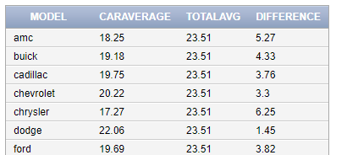

select model, round(avg(mpg), 2) as "CARAVERAGE", (select round(avg(mpg), 2) from car_details) as "TOTALAVG" , round((select avg(mpg) from car_details) - avg(mpg), 2) as "DIFFERENCE"
from car_details cd, car_names cn
where cn.id = cd.id
and mpg is not null
group by model
having avg(mpg) < (select avg(mpg) from car_details)
order by model

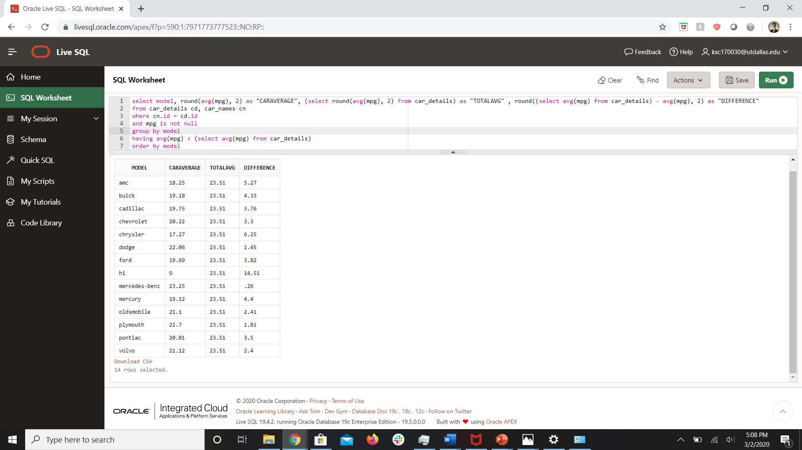

- Provide a count of cars by year and compare that to all cars for all years. List the year, the total number of cars with that year, and then the total number of all cars. Order the rows by years in ascending order.

Sample listing (not all rows displayed)

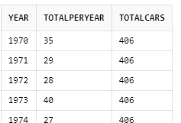

select year, count(id) as "TOTALPERYEAR", (select count(id) from car_details) as "TOTALCARS"
from car_details
group by year

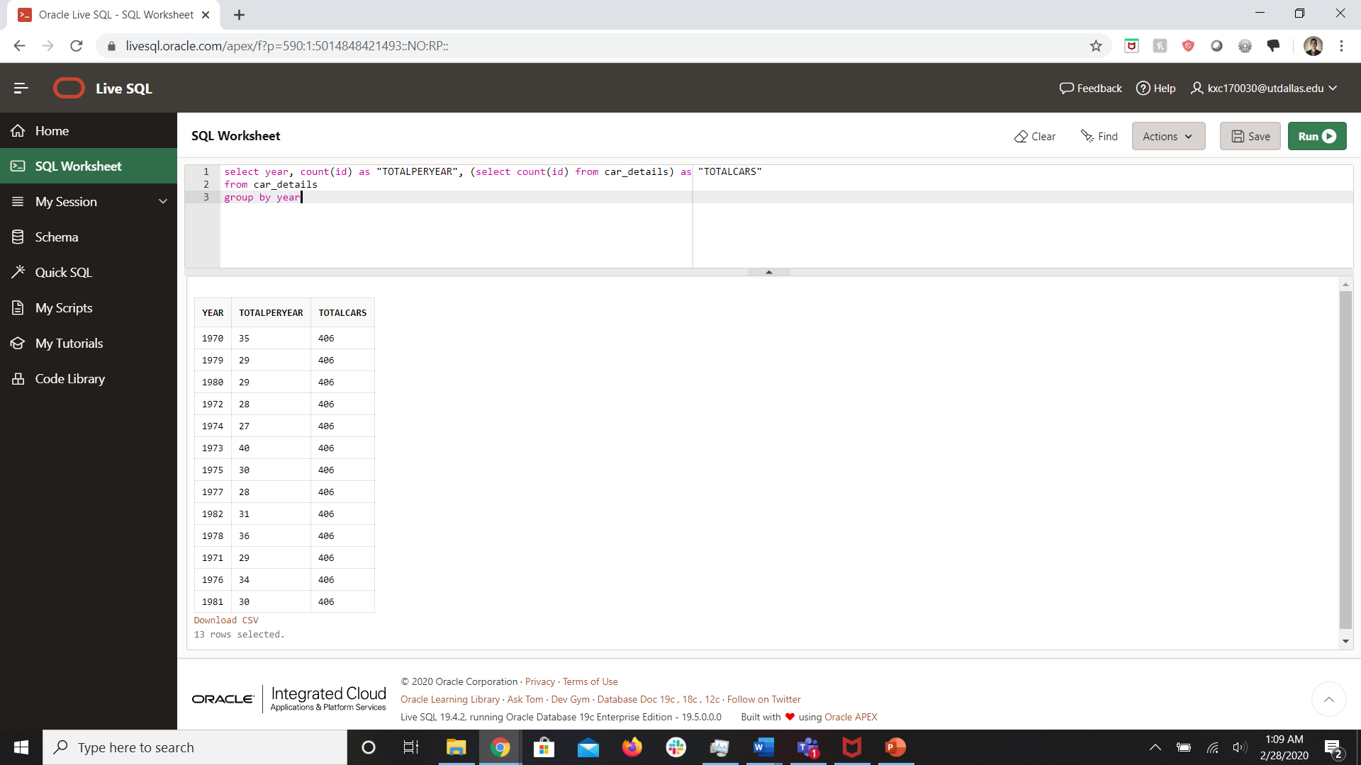
- For each car, list the model, description, year, and the total number of cars purchased that year.

Sample listing (not all rows displayed)

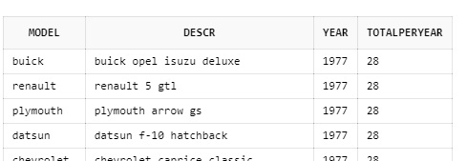

select model, descr, year, (select count(id) from car_details cd1 where cd1.year = cd.year) as "TOTPERYEAR"
from car_names cn, car_details cd
where cn.id = cd.id;

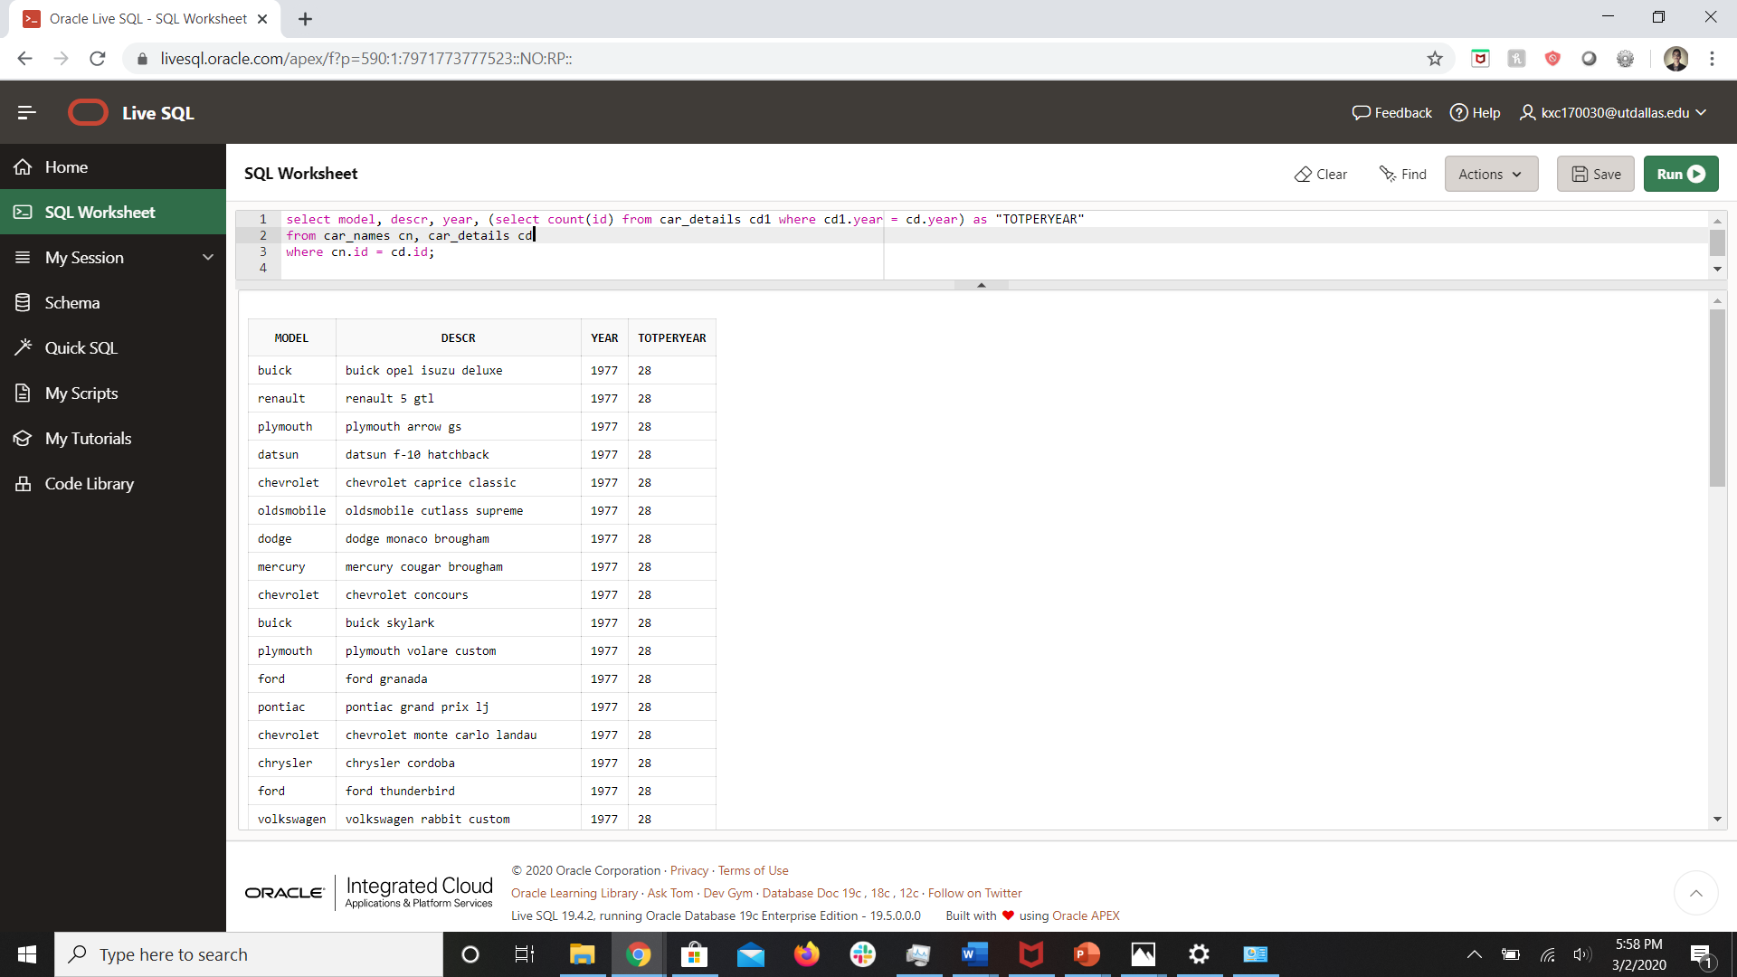
- Provide a breakdown of the market share of each of the car manufacturers using a percentage. (HINT: total number of cars manufactured by a maker / total number of cars produced * 100) You need to know the total number of cars produced by each maker and the total number of cars produced overall. Order the results by market share in descending order. Display the model name with the first letter capitalized.

Sample listing (not all rows displayed)

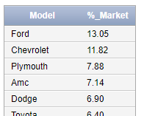

select initcap(cm.maker) as "Model", round(((count(cn.id) / (select count(id) from car_names)) * 100), 2) as "%_Market"
from car_makers cm, model_details md, car_names cn
where cm.id = md.maker
and md.model = cn.model
group by cm.maker
order by "%_Market" desc

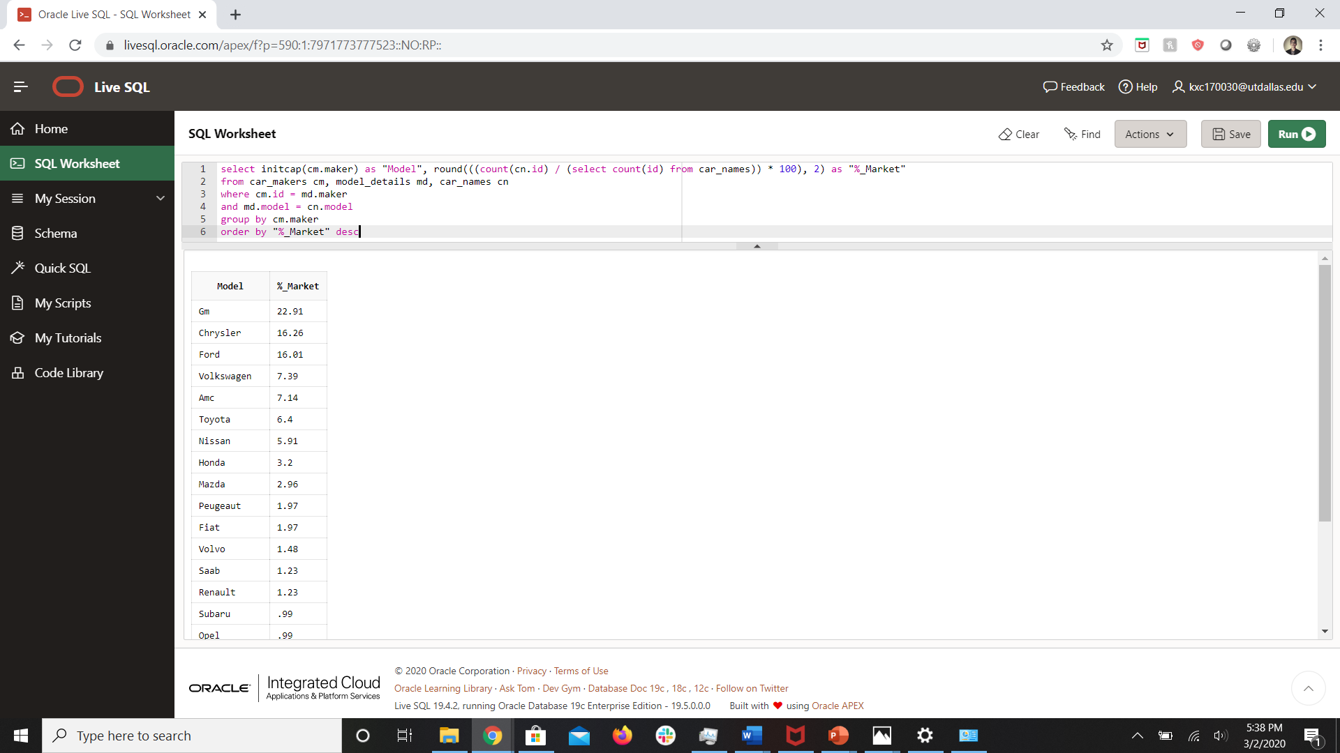

BONUS – modify the query to confirm that the percentages all add up to 100 + 2 pts

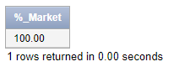

select to_char(sum(((count(cn.id) / (select count(id) from car_names)) * 100)), '999.99') as "%_Market"
from car_makers cm, model_details md, car_names cn
where cm.id = md.maker
and md.model = cn.model
group by cm.maker
order by "%_Market" desc

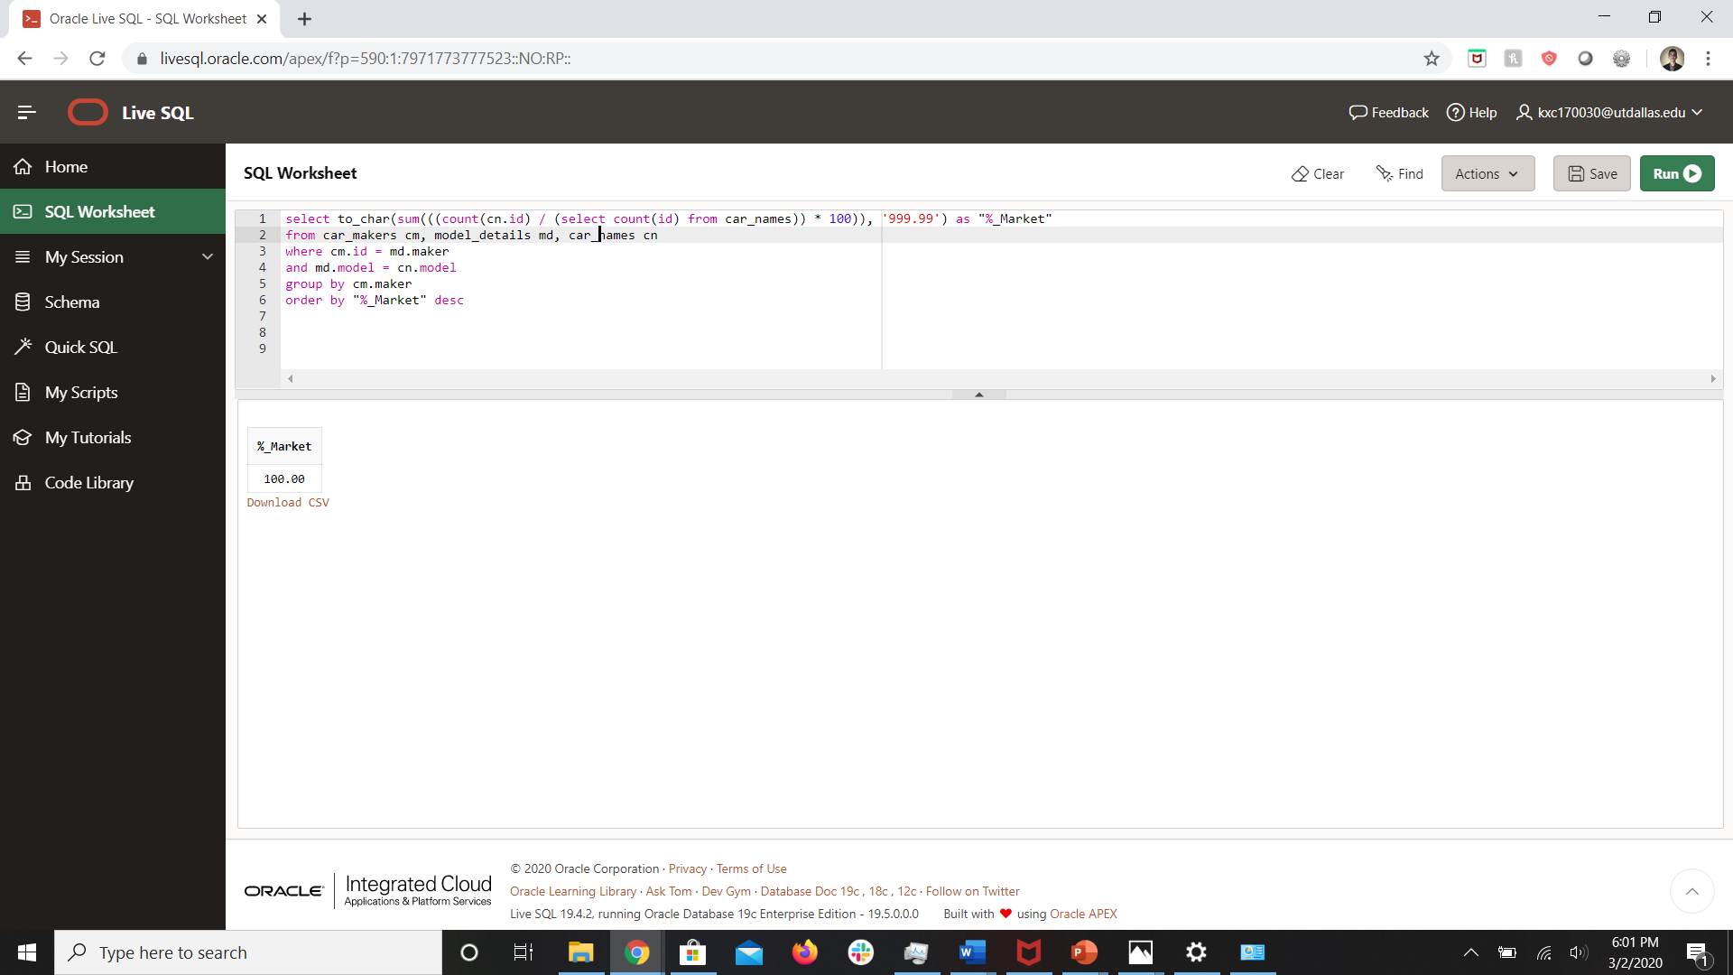
- For each country, list the country id, country name, continent name and the number of cars produced by each country. Order the results by car count in descending order.
Sample listing (not all rows displayed)
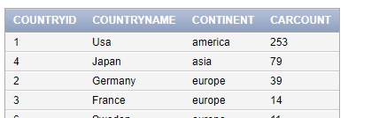
select countryid, initcap(countryname) countryname, con.continent, count(cn.id) as "CARCOUNT"
from continents con, countries coun, car_makers cm, model_details md, car_names cn
where con.contid = coun.continent
and coun.countryid = cm.country
and cm.id = md.maker
and md.model = cn.model
group by countryid, countryname, con.continent
order by CARCOUNT desc
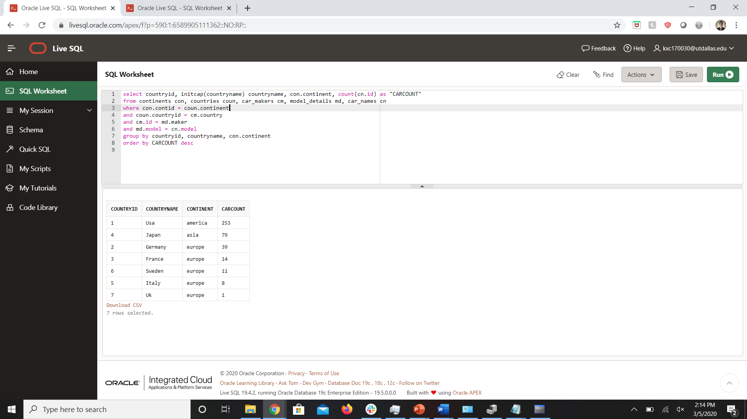
BONUS: Which country produces the most number of cars? To answer this question consider the following nested aggregate function: +5
If you run the following, it will return the total number of cars grouped by country.
select c.countryid, (count(cn.id)) as carscount
from car_names cn, countries c, car_makers cm,
model_details md
where cn.model = md.model and md.maker = cm.id
and cm.country = c.countryid
group by c.countryid
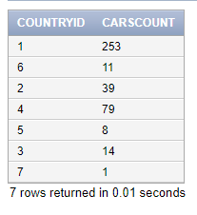
The following is a nested aggregate function that will return the maximum number of cars provided by a single country.
select max(count(c2.countryid))
from car_names cn2, countries c2,
car_makers cm2, model_details md2
where cn2.model = md2.model and md2.maker = cm2.id
and cm2.country = c2.countryid
group by c2.countryid
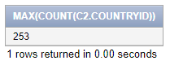
You will need to combine these 2 queries together in some way in order to tell me which country provides the most cars and how many. In order to get full credit, you can’t use rownum or limit. The final output will look like this:
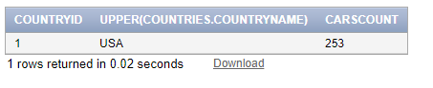
HINT: you will need to use a subquery in the from clause, a subquery in the where clause, and one of them will be correlated.
select countryid, upper(countryname), carscount
from (select countryid, countryname, (count(cn.id)) as carscount
from car_names cn, countries c, car_makers cm,
model_details md
where cn.model = md.model and md.maker = cm.id
and cm.country = c.countryid
group by countryid, countryname) c1
where carscount = (select max(count(c2.countryid)) from car_names cn2, countries c2,
car_makers cm2, model_details md2
where cn2.model = md2.model and md2.maker = cm2.id
and cm2.country = c2.countryid
group by c2.countryid)
